Drs Ridley, Elphick, Thompson, Glennie, Kurian and Marshall
Greystoke Surgery Morpeth NHS Centre The Mount Morpeth Northumberland NE61 1JX
Tel: 01670 511393 Fax: 01670 503282

WELCOME TO GREYSTOKE SURGERY

Your Registered Doctor is Dr H Marshall

We would like to invite you to make an appointment with the Doctor/Nurse. This will give you the opportunity to meet him/her and allow us to obtain some details on your medical history and current state of health. We shall check your blood pressure and test urine, so please bring a specimen with you.

It would be very helpful if you would complete the following questions as best you can

How did you hear about Greystoke Surgery? ………………………………………………………………………………………..………………………

Name.…………………………………………………………………………………………. Date of Birth ……...........................................……

Address ………………………………………………………………………………………………………………………………………………………………….……...

Telephone No. Landline ……………………………………………………. Mobile …….………………………………….……………………….………

Please indicate your preferred method of contact
Post [ ] Home no [ ] Mobile No [ ]

Marital Status ………………………………………..…………………… Maiden Name ……………………………………………………………….…….

Nationality …………..………………………………………….………… Ethnicity ……………………………………………………………................. White/Mixed/Indian/Pakistani/Bangladeshi/Black/Oriental
First Language Spoken ……………………………………………………………………………………………………………………………………………………

We have an email distribution list so that we can send out surveys and also any relevant patient information (such as the Greystoke Gazette and Patient Participation group minutes) direct to patients electronically. We do not use email to exchange clinical information. If you are interested please fill in the details below.

Email Address ………………………………………………………………………………………………………

I consent to Greystoke Surgery sending me useful patient information to the address detailed above.

Signed ……………………………………………………..………………. Print Name …...…………………………………………………………………..

Are you a Carer? Yes / No Do you have a Carer? Yes / No

If Yes please give details
Name ......................................................................... Tel No ................................................................................
Address …………………………………………………………………………………………………………………………………………………………………...

Please tick if you have any of these serious illnesses or conditions:

Asthma [ ] Chronic Kidney Disease [ ] COPD [ ]
Dementia [ ] Diabetes [ ] Epilepsy [ ]
Heart Failure [ ] Hypertension [ ] Stroke [ ]
Osteoporosis [ ] Ischaemic Heart Disease [ ]

Please supply a list of your last Surgery’s repeat medication slip – please attach to this form

Personal Information

Do you have any allergies? …………………………………………………………………….………………………………………………………………………

Do you smoke? Yes / No If Yes, how many a day? …………..…………
If No, have you ever smoked? Yes / No

Are you on a special diet? …………………………..…………………………………………..………............................................................

Which of the following best describes your exercise?

Impossible [ ] Avoid exercise [ ] Light/Moderate [ ] Heavy [ ]

FAMILY HISTORY
Do you have a family history of any medical problems? ……………………………………………………………………………………………………………………………………………………………………………………….
……………………………………………………………………………………………………………………………………………………………………………………….

FOR WOMEN
When was your last cervical smear? …………………….….……. Have you had a breast screen? ………………….…………………….

MILITARY VETERANS

Have you been a member of the Military in the past? Yes / No

If yes, which Service and Regiment? …………………………………………………………..……………………………………………………………………

WE ARE NOW LIVE ON THE SUMMARY CARE RECORD ONLY. IF YOU DO NOT WANT A RECORD CREATED FOR YOU, PLEASE TICK HERE complete an ‘OPT OUT’ form or ask for more information

Our Primary Healthcare Team have full access to our computer system and to your medical records when they treat you, to enable them to carry out their roles fully and give you the best possible healthcare. They will only access your personal information with your consent.

Currently our Primary Healthcare Team consists of:

Doctors, Practice Nurses, Receptionists, District Nurses, Midwives, Health Visitors, Diabetes Dietitians, CPN Nurses, Counsellors and Podiatrists.

Drs Ridley, Elphick, Thompson, Glennie, Kurian and Marshall

Appointment with ………………………………….……………..……… Date……………..………………….. Time…………………………………

Request for identification when registering at the practice.

The Dept of Health has recently become concerned about fraudulent patient registrations so It is important to ask all new patients (whether registering permanently or temporarily) to provide identification upon registering.
A combination of the following can be accepted as identification (one item of photo ID must be seen, along with one document containing the patient’s address):

Birth certificate
Marriage certificate
Medical card
Driving licence
Passport
Paid utility bills
Bank/building society cards/statements
National Insurance number card

Drs Ridley, Elphick, Thompson, Glennie, Kurian and Marshall
Greystoke Surgery Morpeth NHS Centre The Mount Morpeth Northumberland NE61 1JX
Tel: 01670 511393 Fax: 01670 503282

Alcohol Screening Questionnaire
Name
Date of Birth
Address
NHS No (If Known)

Please circle the answer that applies to you.
Questions | Scoring system |  |  |  |  | Your score
 | 0 | 1 | 2 | 3 | 4
How often do you have a drink containing alcohol? | Never | Monthly  or less | 2 - 4 times per month | 2 - 3 times per week | 4+ times per week
How many units of alcohol do you drink on a typical day when you are drinking? | 1 -2 | 3 - 4 | 5 - 6 | 7 - 9 | 10+
How often have you had 6 or more units if female, or 8 or more if male, on a single occasion in the last year? | Never | Less than monthly | Monthly | Weekly | Daily or almost daily

Many Thanks for your time, if you wish to discuss this with us please contact the practice on 01670 511393

TEXT MESSAGING CONSENT FORM

The practice is planning to introduce a mobile texting communication service.

This service will be used to send text reminders to patients regarding upcoming appointments and speak to the doctor / nurse or book an appointment. We may also use this service to contact patients about health promotion.

We always strive to maintain confidentiality of your information and will continue to do so while using this system. To help us do this, it is important that you let us know if you change your mobile number in the future. We will NOT send out any texts unless you have explicitly consented.

If you give consent for us to communicate with you by mobile text messaging as outlined above please fill in your details below. If you decide you no longer wish to receive messages through this service please inform us.

Patient Name:
Date Of Birth:
Mobile Number:
Patient Address:

I confirm that I have read and understood the information above and I CONSENT to the practice contacting me by text message for the purpose of health information and appointment reminders. I will ensure that I keep the practice informed of my up to date mobile number at all times, or if the number is no longer in my possession

Signature of Patient:
Date:

Systm Online

Appointment Booking and Prescription Ordering

Practice Guidelines
All patients wishing to use Systm Online must read the following guidelines and sign to acknowledge acceptance of these terms. Agreement to these guidelines will allow patients on line access to medication requests and appointment booking. Further consent will be required before other services are made available.
- Patients must be aged over 18 years to register for the service.
- The practice will only accept signed applications from individual patients for their own registration details. (For example a wife cannot request registration on behalf of her husband).
- Patients will be required to prove their identity as part of the registration process. You will be asked to provide suitable forms of identification. You will need to present a photo ID which shows your address details for example a photo driving licence. If you don’t have a photo driving licence you will need a passport and utility bill with your address clearly shown.
- Use of your security details by an unauthorised person may allow them access to confidential medical information about you, therefore these details must be kept confidential at all times.
- Your security details (which are the Systm Online User Name and passwords) must be kept safe and secure at all times.
- Patients must NOT share their security details to any other person including family and practice staff. We will NEVER ask you for your security details. If someone asks you for these details please inform the practice immediately.
- You must use all reasonable precautions to protect your security details. This includes not using a public computer for access to the service and using the log off icon when you have finished with the service.
- The practice reserves the right to remove access to this service to any patient who abuses or fails to follow any of these guidelines.
I have read, understood and agree to the guidelines listed above. I agree to keep my security details safe and secure at all times and will take all reasonable measures to prevent unauthorised access to the service.

Signed
Print Name
NHS Number
Date
Staff Authorisation

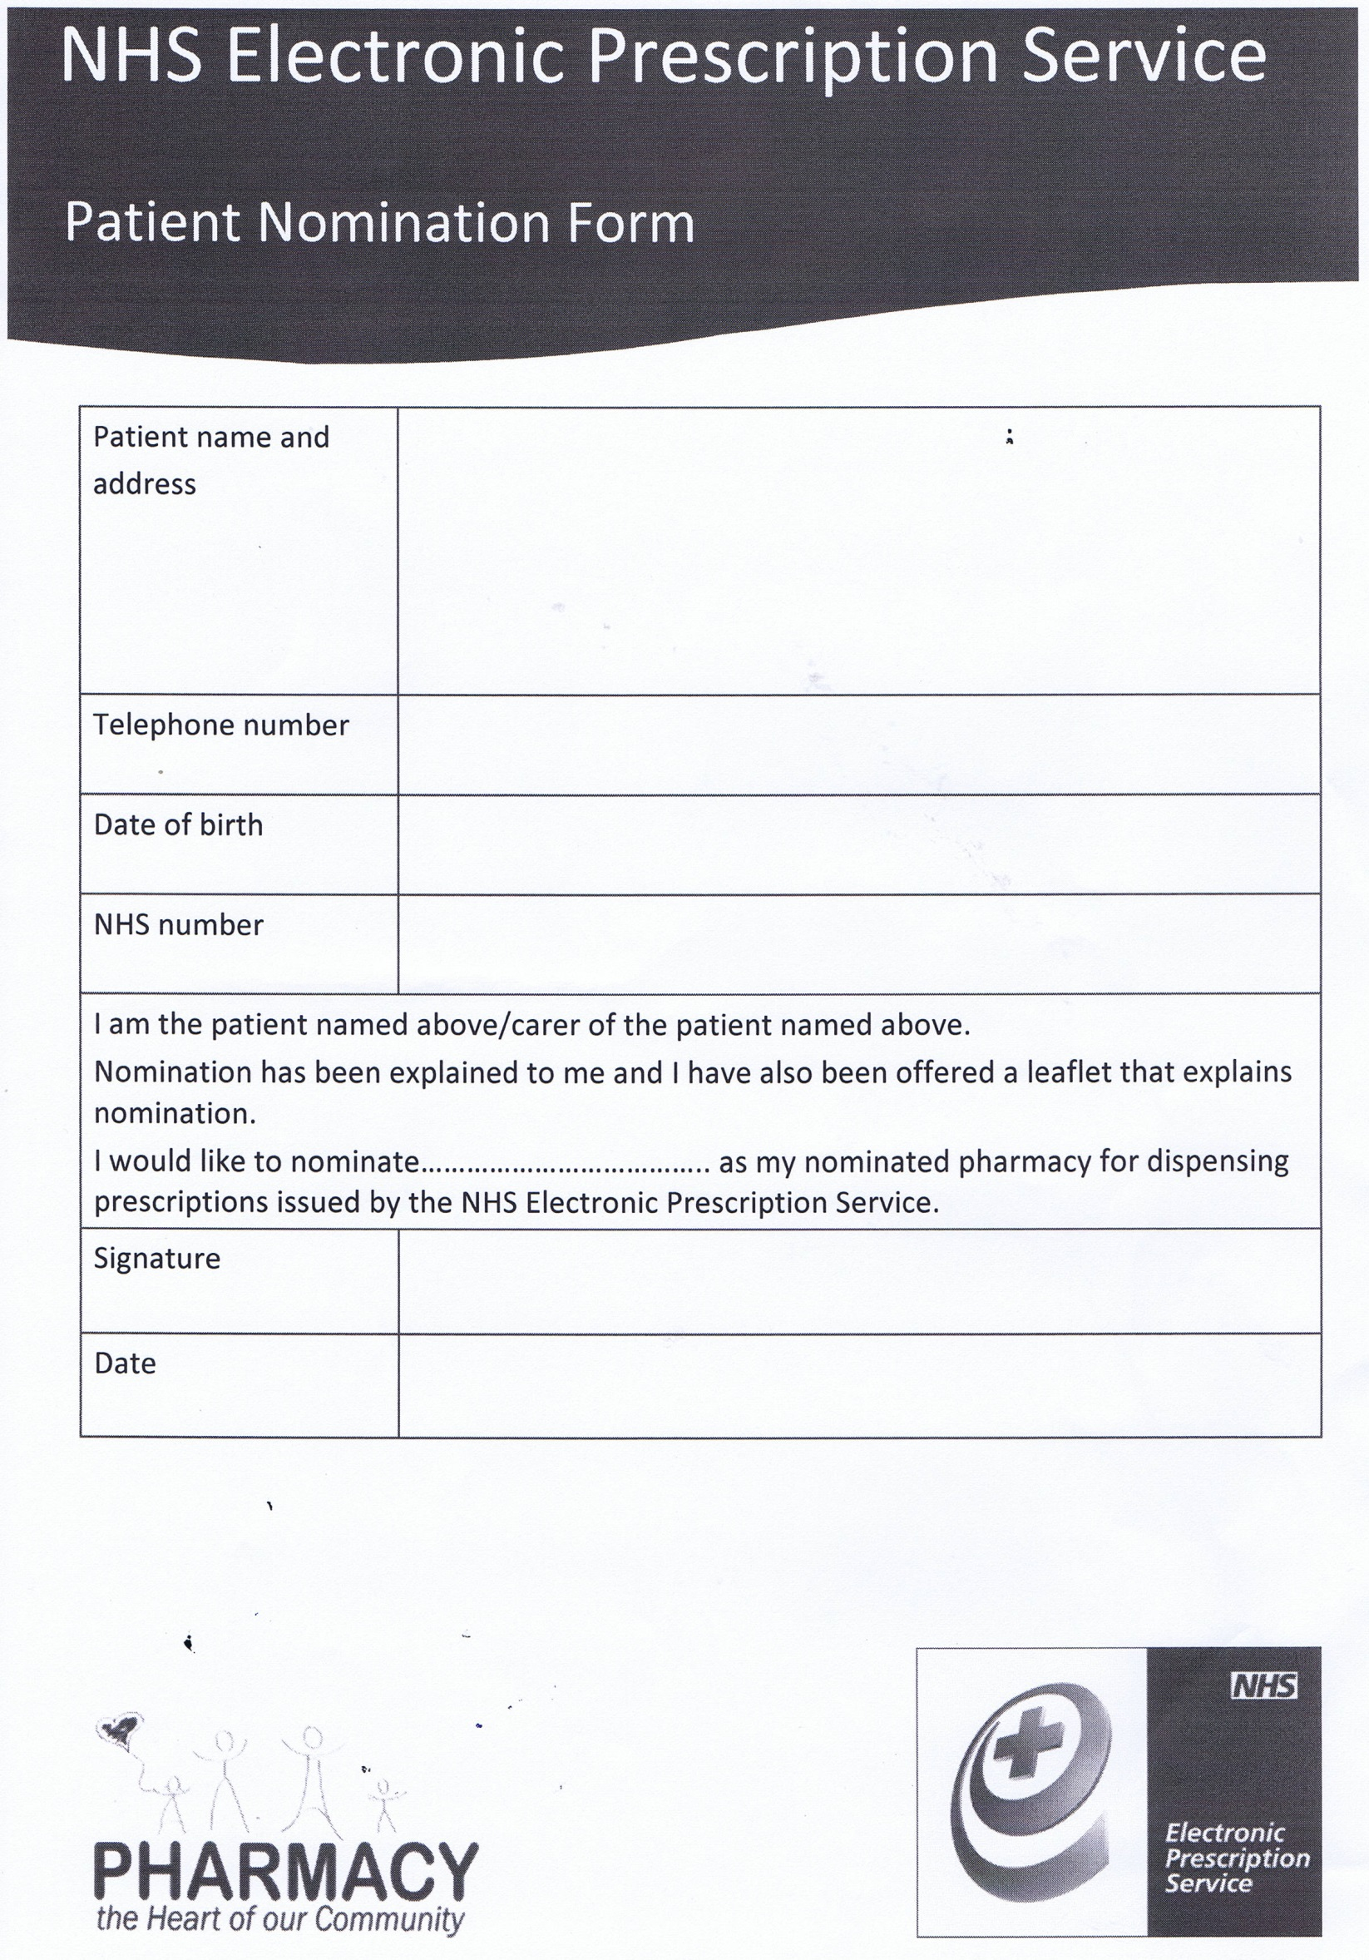

Patient Registration Checklist

- Registration Form □

- Greystoke Practice Patient Questionnaire □

- Two Forms Of ID (from list enclosed) □

- Alcohol Questionnaire □

- Text Message Consent Form □

- SystmOnline Form □

- EPS Pharmacy Nomination Form □

